Contract for Team QORVO_RADIO2

Goals:
- Create a radio module to transmit and receive signals from various devices.
- Achieve high scores in the course
- Have a meeting agenda during every meeting, pushing the project forward
- Effective communication with our industry sponsor
- Strive for first place in the senior design expo.

Ground Rules:

The members of Team QORVO_RADIO2 agree that each member is responsible for demonstrating the following attributes throughout the project:

Attendance at meetings is mandatory and participation is required during these meetings. Meetings may be conducted in person, or online through zoom or discord. Members are expected to be attentive during meetings. Phones and laptops should not be used during meetings unless required to conduct meeting business. Lack of participation will be documented in the Minutes of the Meeting. Members are expected to notify the team of an absence within 24 hours of the meeting. A maximum of 2 excused absences are allowed for each team member. Members are expected to come to meetings prepared with all necessary materials to conduct business. An agenda will be set for every meeting 24 hours in advance, a formal agenda can be disregarded at teams discretion. Tasks and deliverables that are scheduled during a meeting are expected to be done by the time that is agreed upon. If difficulties arise members are expected to address these to the team as soon as possible. Team meetings will be recorded in the “Minutes of the Meeting”, these documents will be posted after each meeting in the shared google drive in the appropriate folder.

Members are expected to communicate with the team throughout the duration of the project. This is subject but not limited to verbal written, and electronic means. Project communication will be done through the team's discord channel. All communication must be conducted in a professional and civil manner. Members must respond within 5 hours of a message sent through the discord, outside of the 10pm-8am quiet hours.

All members are expected to take initiative by volunteering when they can, and should not wait to be told to complete a task. If a member does not have a task this must be communicated to the rest of the team during the next team meeting.

Assignments are to be completed and handed off to the project team lead by 2pm the day the assignment is due. The Project lead is responsible for submitting the assignment by 6pm the day the assignment is due. All work is expected to be of quality and go beyond fulfilling the project requirements, and strive for first place in the senior expo competition. All members are expected to work on a critical part of the project.

Members are to report all use of AI to the rest of the team.

Members are expected to use data and facts to drive decisions and encourage open discussion of ideas amongst the team before an option is chosen. All members are expected to give input.

Conflicts are to be handled in a professional and civilized manner. Members are to choose an appropriate time and place to discuss conflict and are expected to maintain civil rapport during these discussions. The Code of Student Conduct is to be followed at all times. Members are expected to find common ground and seek resolution during these discussions.

When completing peer evaluations all ground rules will be appropriately evaluated.

Members agree to put their best effort into completing their parts of the project.

Consequences:

- Members are expected to bring food to the next meeting for missing meetings without an excused absence.
- Verbal warning after 2 unexcused absences.
- Written warning after 3 unexcused absences.
- After 4 absences a letter grade will be dropped per absence on peer evals and mentors will be notified.
- Tardies are 10 min late. After 2 tardies a verbal warning is issued.
- After verbal warning every 2 tardies is counted as an absence.
- After 3 participation warnings, the member is to bring food to the next meeting.
- After 4 participation warnings, noted in peer review.
- Failing to respond to communication counts as a participation violation.
- Failing to complete assignments by due time is immediate deduction from peer evaluation.

We agree to adhere to these ground rules and consequences effective 8/29/2025.

Member, print and sign name: Luke Matthews, 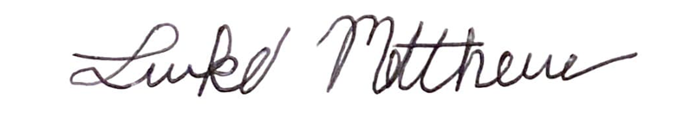

Member, print and sign name: Alberto Hernandez , Alberto Hernandez

Member, print and sign name: Abdul Bah, 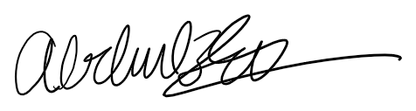

Member, print and sign name: Ethan Hartman, Ethan Hartman
Member, print and sign name: Kenneth Le,
Kenneth Le

Date: 08/29/2025

